# Chapter 3 Programming Project

Complete this programming project using your notes, the text book, and any online or in-class sources you like. Your work must be your own; you may ask a friend to look over your work, or discuss procedural decomposition with you, but you must write all code on your own. Don’t forget to use your 4 commandments of scope and error-checking algorithm.

**To receive full credit on this lab, you MUST submit a structure diagram or pseudocode-plan with each question.**

Exercise 1

*Princess Luna and Celestia are going on a tour of the kingdom to greet the other citizens of Equestria. Their tour takes them on a circular path (shown on map on next page). Write a method called roadTrip that (1) accepts as a parameter the diameter of the circular path, and (2) returns the length of the trip. Hint: Your main method should call the roadTrip method with a parameter.*

*The equation for circumference is: C = dπ*

*Java has a math constant called Math.PI.*

Exercise 2

*Write a method called distance that (1) accepts four integer coordinates: x1, y1, x2, y2 as parameters, (2) computes the distance between points (x1, y1) and (x2, y2) on the map, and (3) returns that distance.*

*The equation for the distance is: $d= \sqrt{{(x2-x1)}^{2}+ {(y2-y1)}^{2}}$*

*Test out your program by writing a main method that calls the distance method for each of the following pairs of cities. Your main method should output the value returned by the distance method.*

*Distance from Baltimare (29, 16) to Manehattan (34, 8)=*

*Distance from Los Pegasus (6, 19) to Neighagra Falls (22, 7)=*

*Distance from the Badlands (25, 24) to Ponyville (16, 14)=*

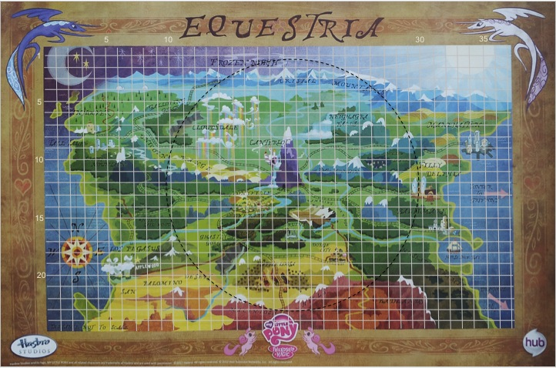

## Exercise 3

*Write a program that helps Princess Luna plan a 3-stop tour of Equestria. Princess Luna has specifically requested that you choose three destinations in Equestria, as defined by their x and y coordinates on the map. You program should output the distance between the three.*

*You should use the distance methods you wrote for Exercise 2.*

Exercise 4

*Write a method called totalTrip that accepts parameters for 3 locations (each containing coordinates) and returns the total distance traveled by visiting all 3 locations and returning to the starting location. You should use the distance methods you wrote in Exercise 2 and you can choose any 3 locations in Equestria.*

*Extra credit: make this program compute 4 locations instead!*